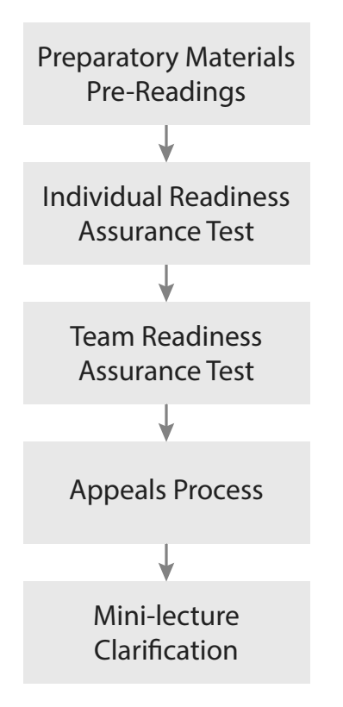
Where is the Power in the RAP?
TBL’s Readiness Assurance Process is a carefully scripted five stage process. There are major synergies between the stages, but in this following situation which stage has the most learning?
Step 1: Consider this Specific Concrete Situation
Dr. Lence has been using TBL for 3 years in a small 2nd year Sociology class. Each year there are approximately 30 students. It is mid-October, and the 3rd module is just starting, so students have completed two RAP cycles and two TBL modules. The class average for the first two RAP cycles was 55% for the iRAT’s and 86% for the tRAT’s
There was some student grumbling after the 1st RAP about not knowing what to read, what to focus on, and testing before teaching makes no sense. As a result of this feedback, Dr. Lence spent some class time working with students to improve their reading skills. It seemed to work - grades went up, students seemed happier, and students seemed better prepared for the 2nd RAP.
Today has been a typical RAP class – a 12 question iRAT, followed by the tRAT (using same test and IF-AT cards), followed by an Appeals Process, and finally Dr. Lence gave a short 4-minute mini-lecture on 2 concepts that students asked for more clarification.
- Today’s iRAT average 69%
- Today’s tRAT average 95%
- Today - 1 appeal (from team that has appealed every RAP cycle – their appeals are typically found to be without merit – therefore denied)
Step 2: Complete Individual Situational Analysis
Try to imagine the amount of learning that took place at each stage of today’s RAP cycle.
Individually, consider how much learning is going on each of the 5 RAP stages. Once you have considered this specific situation, provisionally distribute 100 points across the RAP stages (nominally 20 points per stage). Assign more points to stages that in your opinion resulted in more learning.
Step 3: Pool analysis, achieve consensus, prepare to report
Compare your scores with your teammates, come to consensus on a points distribution. Write your team consensus scores for each stage on the provide sheet of paper.
Give the sheet of paper to instructor at end of analysis time. Team points distributions will be transcribed to table on board and simultaneously revealed.
Be prepared to defend your points distribution.

Is it a 4S activity?
Step 1: Watch Video - https://youtu.be/F0AjCC0Rpgc
Watch the video clip and decide to what extent this is a good TBL 4S example.
Specifically, analyzing if each 4S component is present and how well it is implemented?
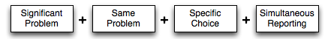
Step Two: Complete individual analysis
Determine for yourself the extent the video is a good example of TBL 4S’s.
On a scale of 0-10 - Ten for a perfect example of 4S and Zero if no components of 4S were seen. (nominally 2.5 points per S)
Be prepared to say WHY
Step Three: Pool analysis, achieve consensus, prepare to report
Compare your score with your teammates, discuss, and come to a team consensus.
Write your team’s score on a sheet of paper and prepare to hold it up when you are prompted.
Be prepared to say WHY.
Writing a good 4S question prompt
You have become the TBL “expert” at your school and have been asked to help a faculty colleague’s their TBL materials.
You are working with an instructor in a first-year English instructor. They are creating an assignment about the use of the active and passive voice. You are coaching them to create an assignment that is both cognitively challenging and will create a rich reporting discussion.
They have come up with a series of possible assignment prompt wordings and now want your guidance in selecting the best wording. Which of the following wordings would be the best for a TBL 4S activity, that is both cognitively challenging and will lead to a spirited reporting discussion?
A. List the mistakes writers frequently make that detract from their efforts to write in an active voice.
B. Read the following passage and identify clear examples of active voice and passive voice.
C. Read the following passage and identify the sentence in which the passive voice is used most appropriately.

